

International Student Guide

**TRAVEL TO CANADA**



Global Education



`Alliance

**Contents**

Introduction 1

Government of Canada's travel regulations and restrictions 2

Who can enter Canada 2

Approved for a study permit. 2

Entry documents checklist. 3

Guidance of 14-day self-isolation plan information. 4

Global Education City. 5

GEC arranging isolation accommodation. 5

GEA self-isolation Services. 5

Self-isolation Services. 6

Before you arrive in Canada. 7

Arrival in Canada. 7

Assessment on arrival. 7

Appendix 1 - B.C. self-isolation plan. 8

Appendix 2 - Federal ArriveCAN application 9

Appendix 3 - Tips for safer social interactions 10

Global Education

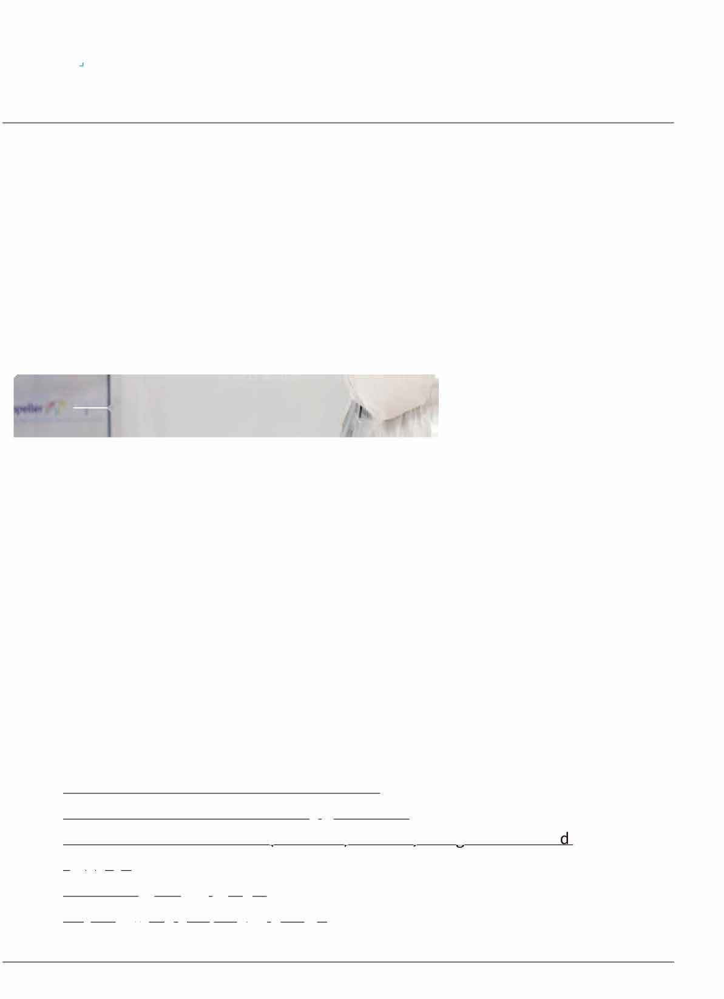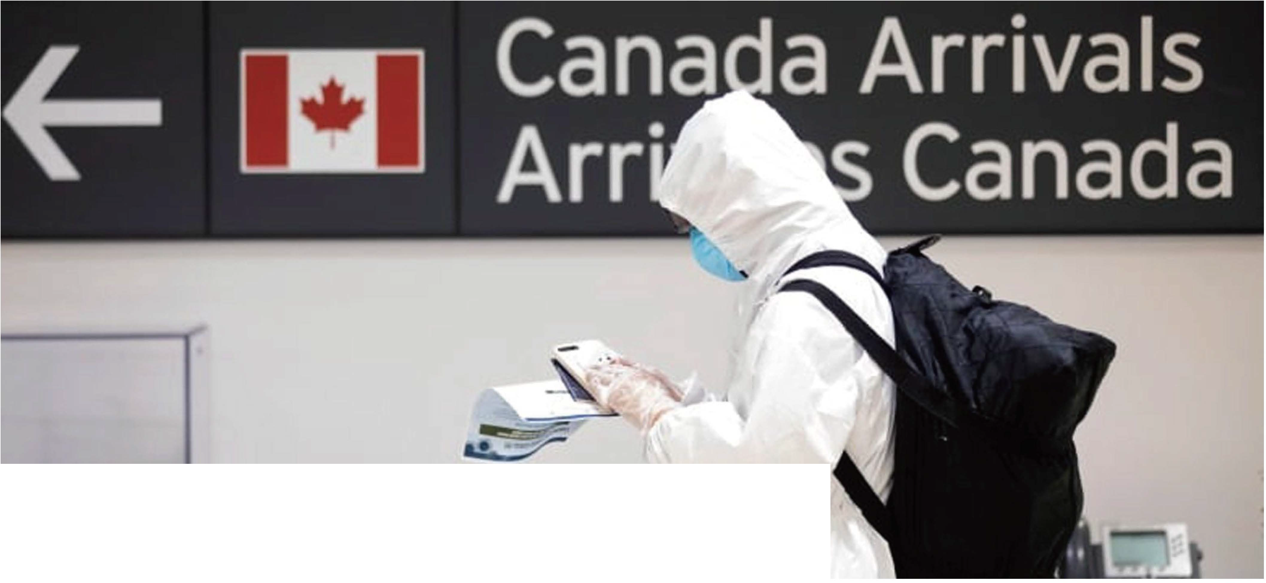

`Alliance

b

# INTRODUCTION

This *International Student Entry Guide*-Travel to Canada is for all new and returning international students who are currently outside of Canada and planning to travel to Canada to start their program incoming term.

Due to the COVID-19 travel restrictions, international students must have a clear understanding of the laws and regulations of the Government of Canada and the BC government. Students must enter Canada for Non-Discretionary purposes only, and have a quarantine plan, and be prepared for a 14-day self-isolation upon arrival in Canada.

For the most up-to-date information and instructions, please review the following government websites:

．

[Government of Canada Travel Restrictions](https://www.canada.ca/en/public-health/services/diseases/2019-novel-coronavirus-infection/latest-travel-health-advice.html) [Government of Canada Mandatory Quarantine](https://www.canada.ca/en/public-health/services/diseases/2019-novel-coronavirus-infection/latest-travel-health-advice.html#f)

．

[IRCC – Coronavirus Disease (COVID-19): Visitors, foreign workers and students](https://www.canada.ca/en/immigration-refugees-citizenship/services/coronavirus-covid19/visitors-foreign-workers-students.html#restrictions-students) [IRCC How to Isolate at Home](https://www.canada.ca/en/public-health/services/publications/diseases-conditions/covid-19-how-to-isolate-at-home.html)

．

[British Columbia Self-Isolation Plan](https://www2.gov.bc.ca/gov/content/safety/emergency-preparedness-response-recovery/covid-19-provincial-support/self-isolation-on-return)

1

Global Education



`Alliance

## GOVERNMENT OF CANADA'S TRAVEL REGULATIONS AND RESTRICTIONS:

It is important to know if you are permitted to travel to Canada, you travel for a [non- optional or non-discretionary purpose and keep yourself updated on the](https://www.canada.ca/en/immigration-refugees-citizenship/corporate/publications-manuals/operational-bulletins-manuals/service-delivery/coronavirus/temporary-residence/study-permit.html#toc_2)

federal and provincial government's travel regulations, restrictions and exemptions. Canada's travel restrictions may prevent you from being able to travel to Canada until further notice.

International students who are able to enter Canada must satisfy both a 14-day [quarantine requirement mandated by the federal government in addition to](https://www.canada.ca/en/immigration-refugees-citizenship/services/coronavirus-covid19/travel-restrictions-exemptions.html#quarantine) submitting a [BC Self-Isolation Plan](https://www2.gov.bc.ca/gov/content/safety/emergency-preparedness-response-recovery/covid-19-provincial-support/self-isolation-on-return) as required by the provincial government. (see Appendix 1 and 2 for details)

**WHO CAN ENTER CANADA (NON-DISCRETIONARY PURPOSE INCLUDES):**

1. Already live in Canada
2. Need to be in Canada for your program
3. School is not offering online study options
4. Your home country has internet restrictions or bandwidth limitations
5. Students cannot participate in live online courses from your home country because of the difference in time zones

## APPROVED FOR A STUDY PERMIT:

1. An international student with a valid study permit or who was approved for study permit on or before March 18, 2020
2. Traveling directly from the US

2

Global Education

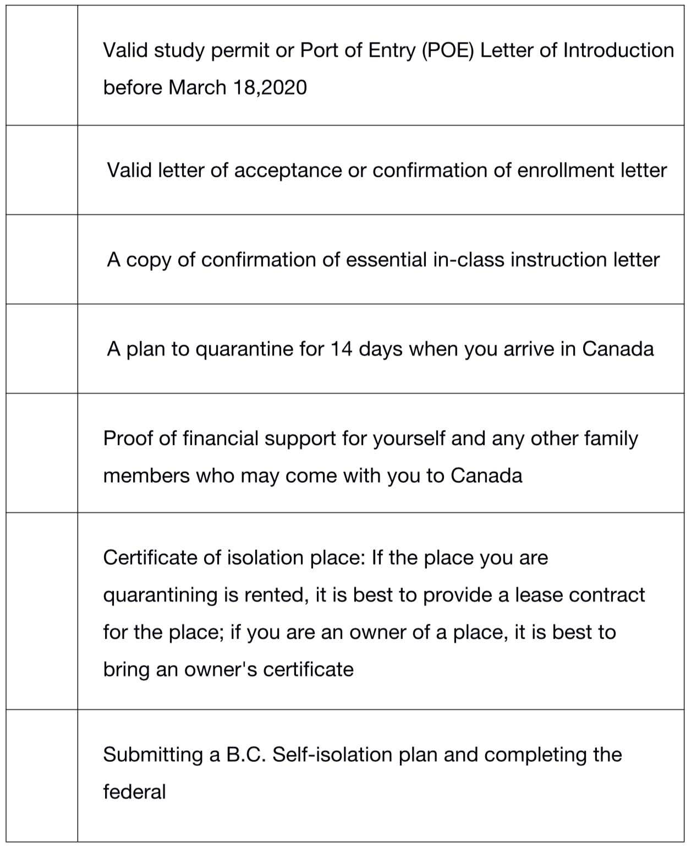

`Alliance

## ENTRY DOCUMENTS CHECKLIST

Before traveling to Canada, prepare and double-check that you have these documents with you at all times and do not put them in your checked luggage. You may not be allowed into Canada if any of your documents are missing or if any of the information on your application or letters of reference is incorrect. For more information, please visit [Entering Canada.](https://www.bcit.ca/international-students/permits-visas-status/entering-canada/)

Before traveling to Canada, prepare and double-check that you have all of your important documents including:

Valid study permit or Port of Entry (POE) Letter of Introduction before March 18,2020

Valid letter of acceptance or confirmation of enrollment letter

A copy of confirmation of essential in-class instruction letter

A plan to quarantine for 14 days when you arrive in Canada

Proof of financial support for yourself and any other family members who may come with you to Canada

Certificate of isolation place: If the place you are quarantining is rented, it is best to provide a lease contract for the place; if you are an owner of a place, it is best to bring an owner's certificate

[ArriveCAN Application](https://www.canada.ca/en/public-health/services/diseases/2019-novel-coronavirus-infection/latest-travel-health-advice.html#ua)

3

Global Education

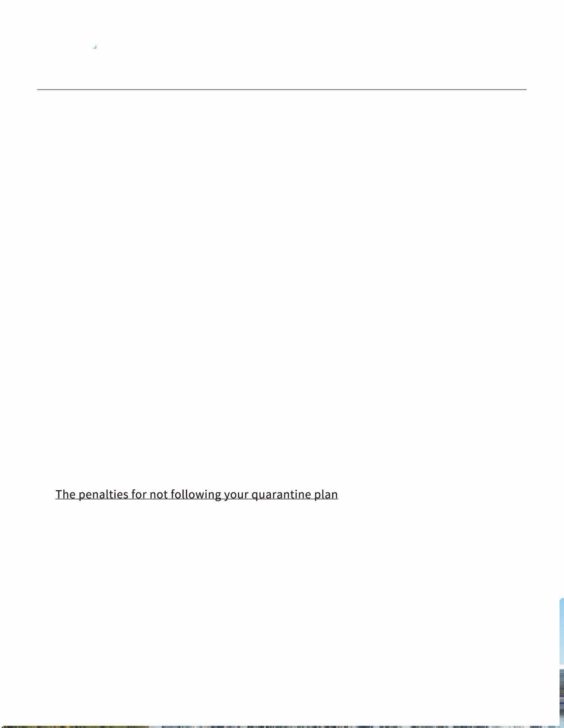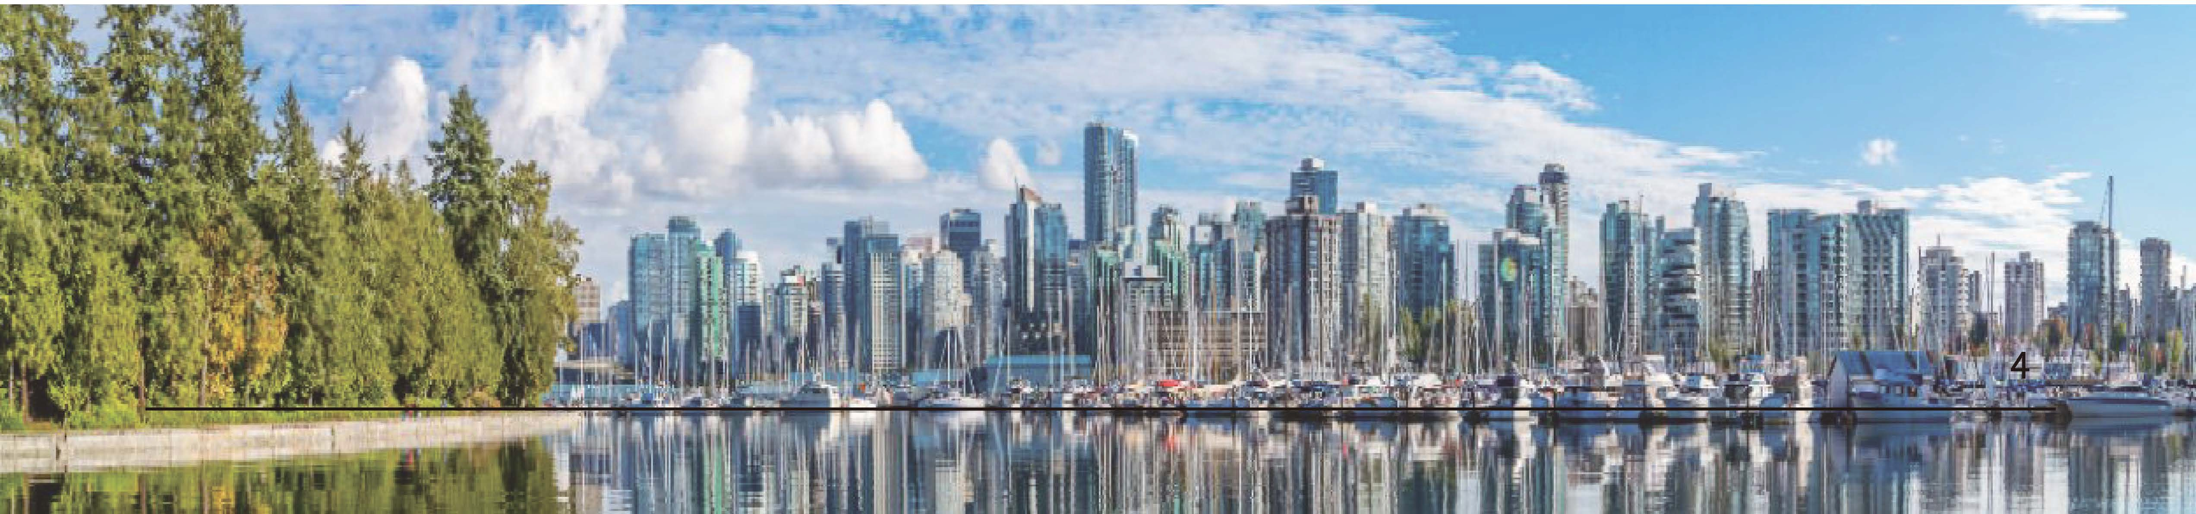

`Alliance

## GUIDANCE OF 14-DAY SELF-ISOLATION PLAN INFORMATION

This plan is mandatory, even if you have no symptoms. If you don't have a plan, you should not travel to Canada. Otherwise, you may not be allowed to enter the country. A border services officer will determine if you can enter the country.

� Route to Canada. (Flight number, time, transit place, etc.)

仁 Transite : How to get from the airport to the isolation place. (Drive by

yourself or with friends, specific protective methods you will follow during the way from airport to an isolation place, etc.)

O Accommodation: The detailed address and living conditions of the self- isolation place (whether there is a separate bathroom, whether there are elderly people over 65 years old living together, etc.)

@ Food: How to solve the daily meal ration during self-isolation.

� Contact Information: If you need help from others from the airport to the

end of the quarantine period, such as the pick- up driver information, helpers' information for your daily necessities deliver, your landlord information, etc., their names and contact information must be stated.

& Your access essential services (Daily necessities consumption)

0 Medications & medical care

I [The penalties for not following your quarantine plan](https://www2.gov.bc.ca/gov/content/safety/emergency-preparedness-response-recovery/covid-19-provincial-support/self-isolation-on-return) once you're in the country

* can include:
  + A fine of up to $750,000
  + 6 months of jail time
  + Being found inadmissible, removed from Canada and banned from entering for 1 year

**Global Education**

**`Alliance**

**SELF-ISOLATION PLACE**

**GLOBAL EDUCATION CITY**

GEC (Global Education City) is Vancouver's leading student residence and accommodation, providing the best living experience to enhance your university journey. Located in the heart of Downtown Vancouver, GEC Granville Suites provides fully serviced hotel suites and care packages for self-isolating students and guests.

**GEC ARRANGING ISOLATION ACCOMMODATION**

* Isolation accommodation
* Safe way to travel straight to home
* Arranging food, grocery and other necessities

Fully serviced suites for self-isolation

O

晶

♦？♦

Social distancing measures in place

WiFi. utilities. cable, and local calling

Hourly disinfection and deep cleaning

-

＿ ＿

。

Self-isolation care package

心

＊＊＊

24/7 front desk reception

##### 鱼 HOMESTAY

Photos were taken pre-pandemic

**GEA SELF-ISOLATION SERVICES**

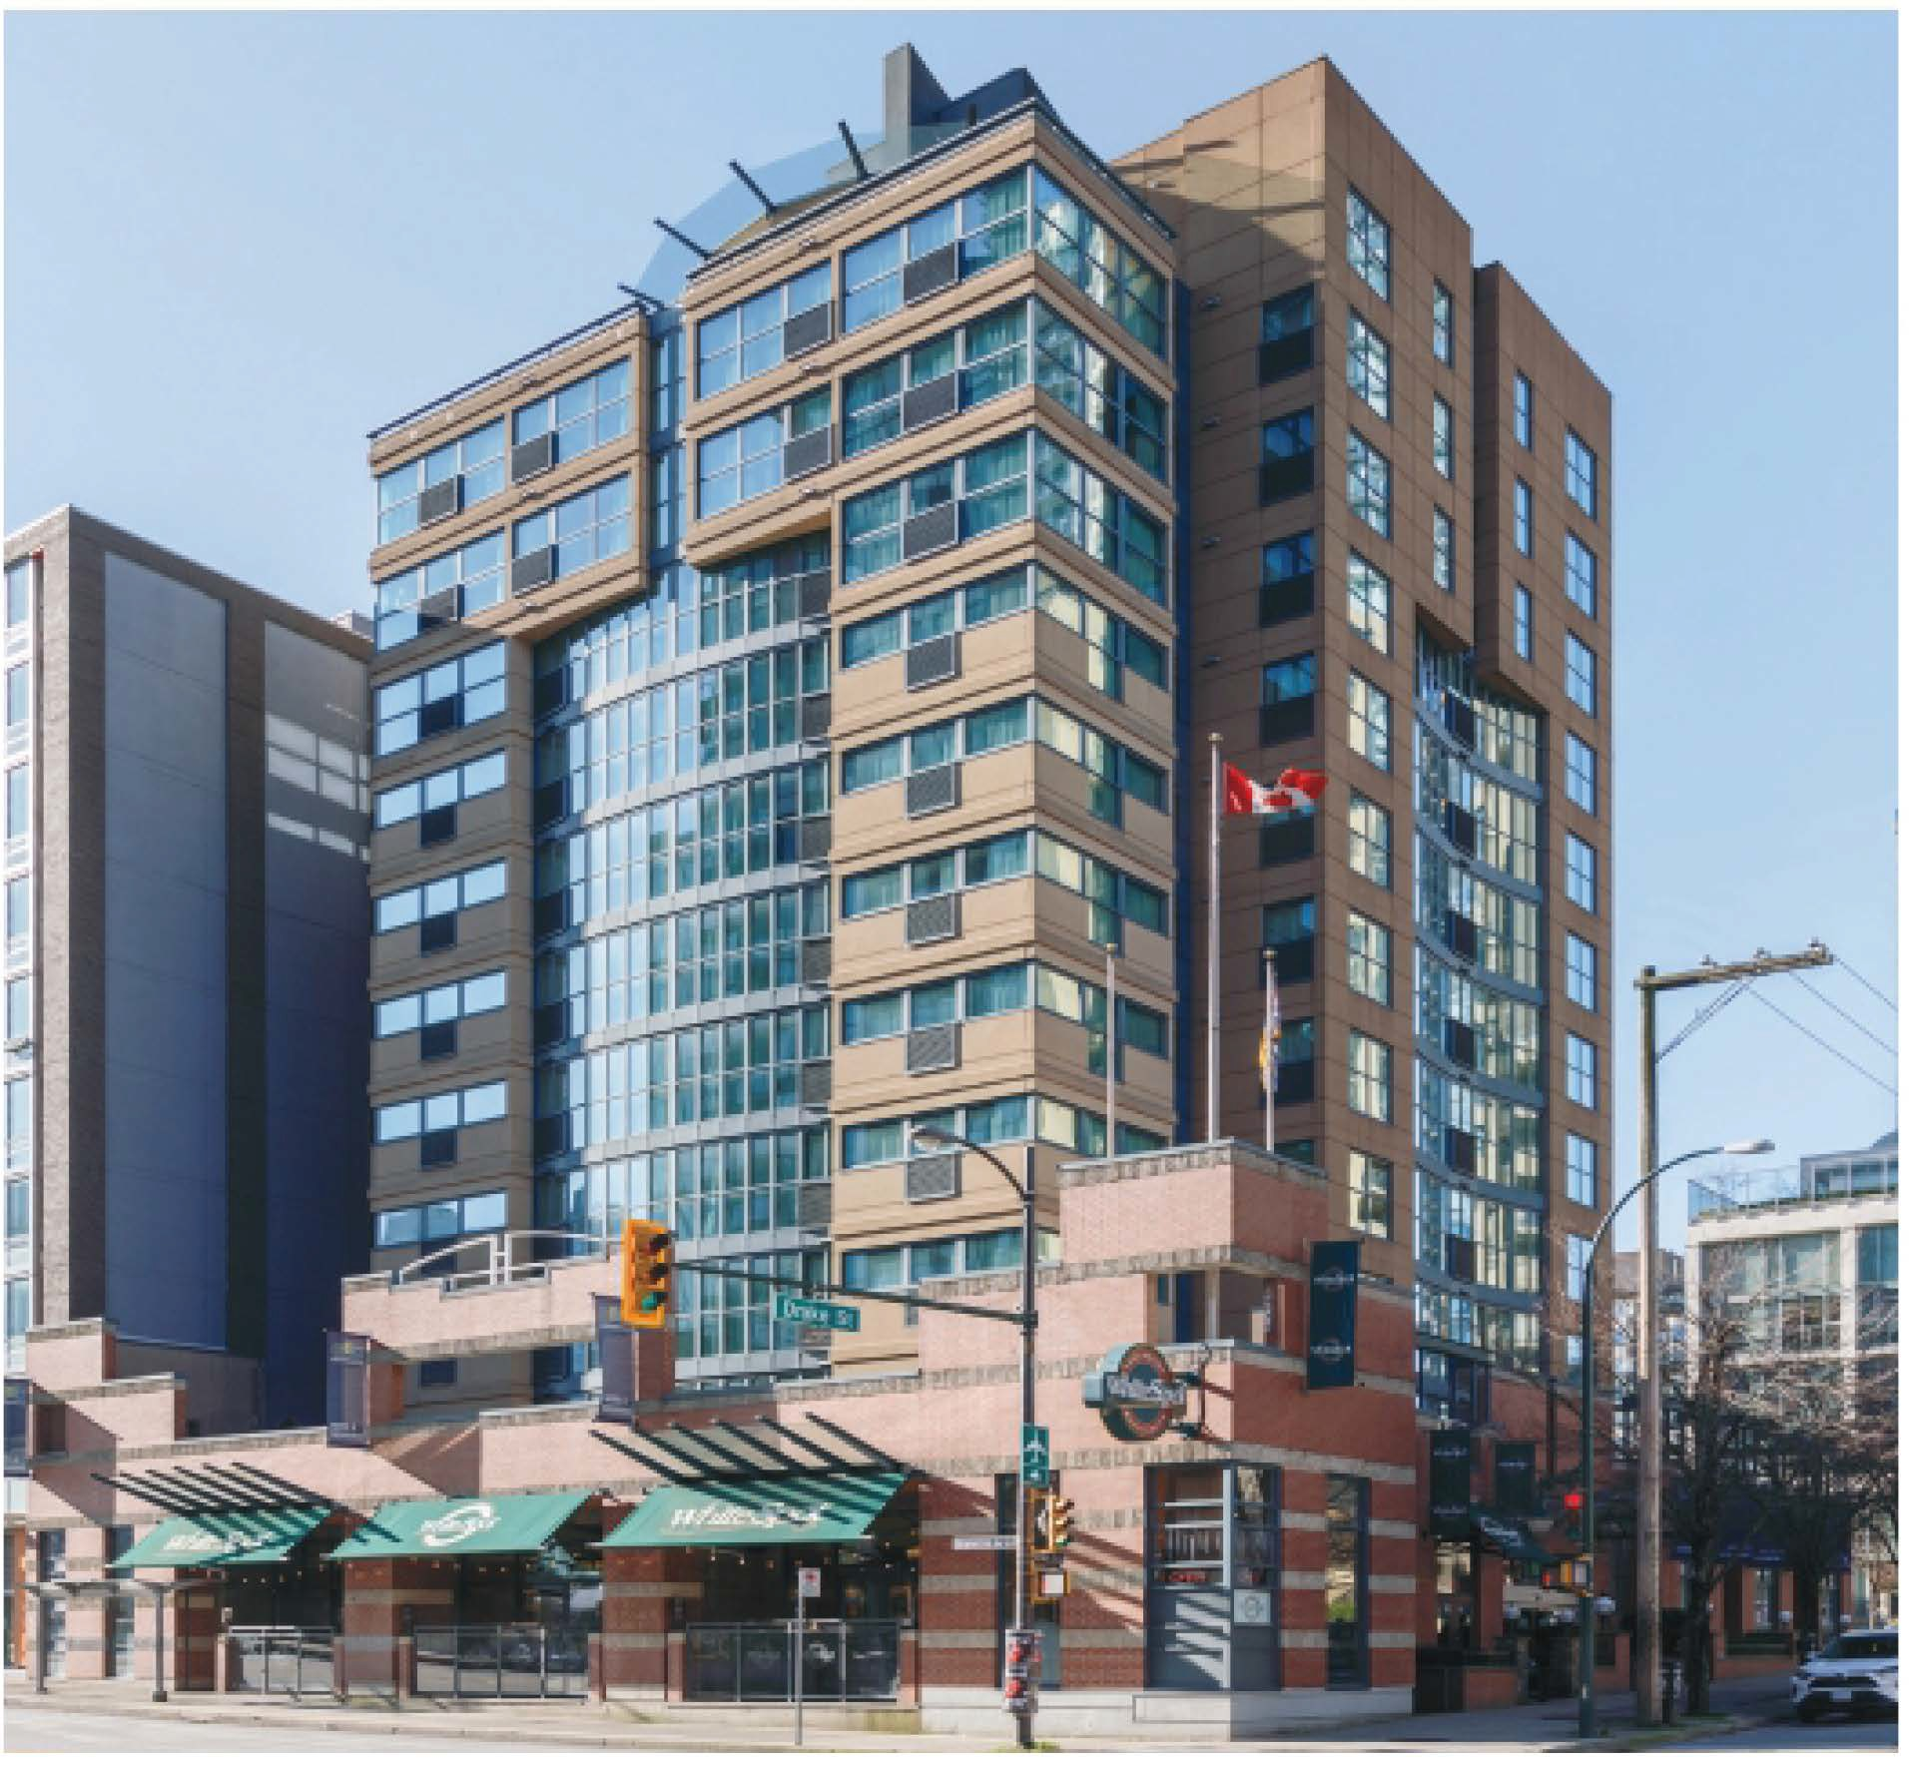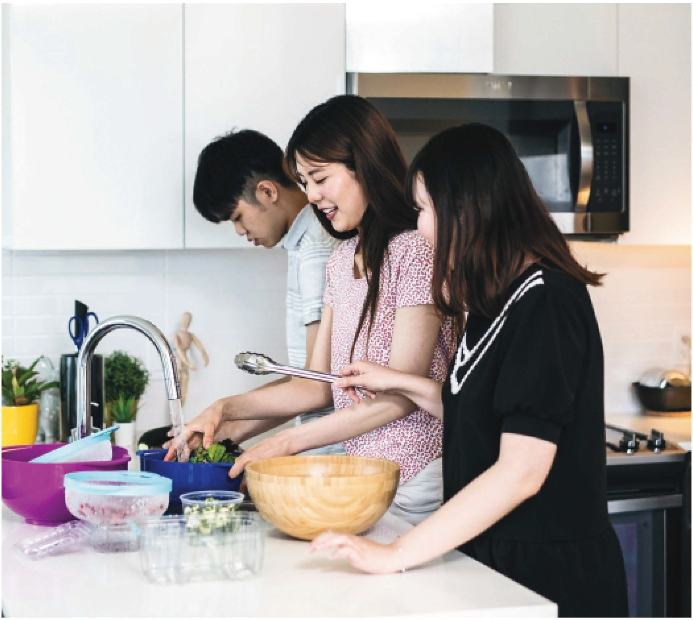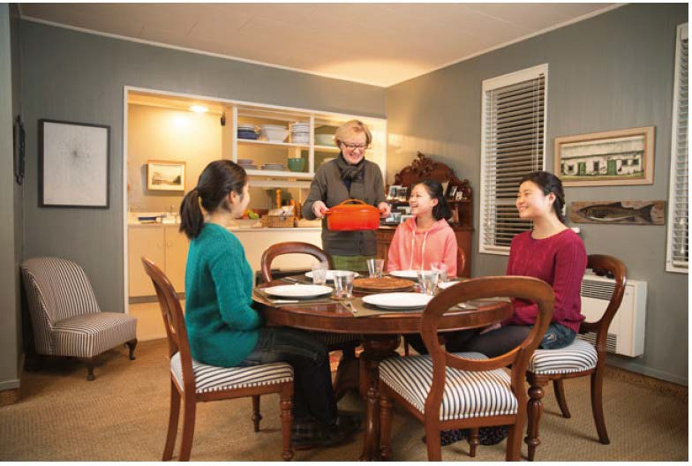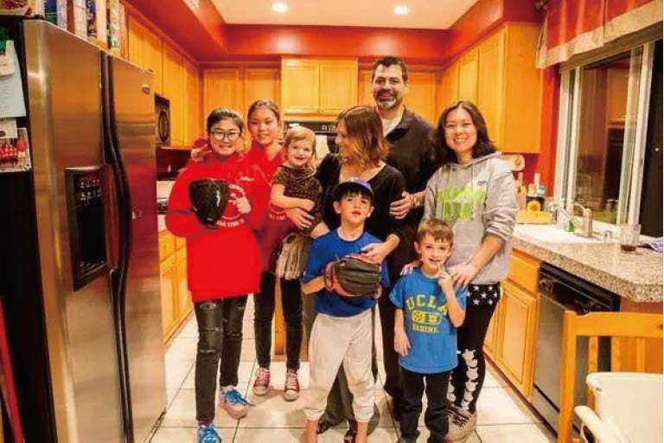

* + Homestay arrangement
  + Medical insurance
  + Airport pick-up

Global Education Alliance(GEA) is a partner of Global Education City(GEC), all GEA students enjoy free accommodations for 14-day self-isolation when they book a minimum of 6 months at any GEC location.

We provide students with hundreds of various types of homestay options

For more information, please contact us at: [service@mygea.ca](mailto:service@mygea.ca)

*5*

Global Education

`Alliance

**SELF-ISOLATION SERVICES**

**ENTERING CANADA**

♦

Once your booking is confirmed, we will send you a confirmation letter, which you can

**CARE PACKAGE**

Before you check-in, your suite will be stocked with our welcome care package, which includes:

心

provide when entering the Canadian Border.

##### 溢 FOOD & GROCERY DELIVERY

Travelers to Canada who are in the quarantine may not go out to purchase food and basic necessities.

* Toiletries (shampoo, conditioner, body lotion,

soap, toothbrush, toothpaste)

* Face masks
* Hand sanitizer
* Disinfectant wipes
* Snacks
* Bottled water

We will provide students delivery service to deliver what you need while you are self-isolating. Also can pick-up and deliver groceries and other essentials to you from these stores.

＿

Walmart �:�

．器话蒜钳挡

##### 中 AIRPORT PICK-UP

You must travel straight to your Vancouver home from airport by personal car, taxi or ridesharing. The airport pick-up service ensures that your mode of transportation from the airport to your home is as safe as possible.

Visit [Beaton's Meet & Greet's](https://www.beatonsmg.com/) website to arrange for pick-up from YVR Airport to GEC.

[For more information, please see their travel guide](https://www.beatonsmg.com/travel-guide).

stapleser

7-．

**SELF-ISOLATION SUITES**

**Queen Suite**

$1300/14 nights

Uber

**Double Beds Suite**

$1300/14 nights

lyA 面

**Kitchenette Upgrade**

心200/14 nights

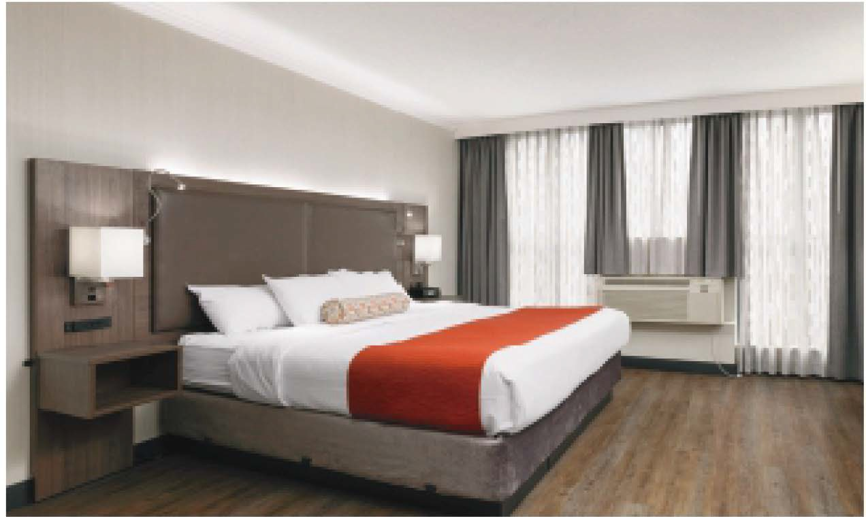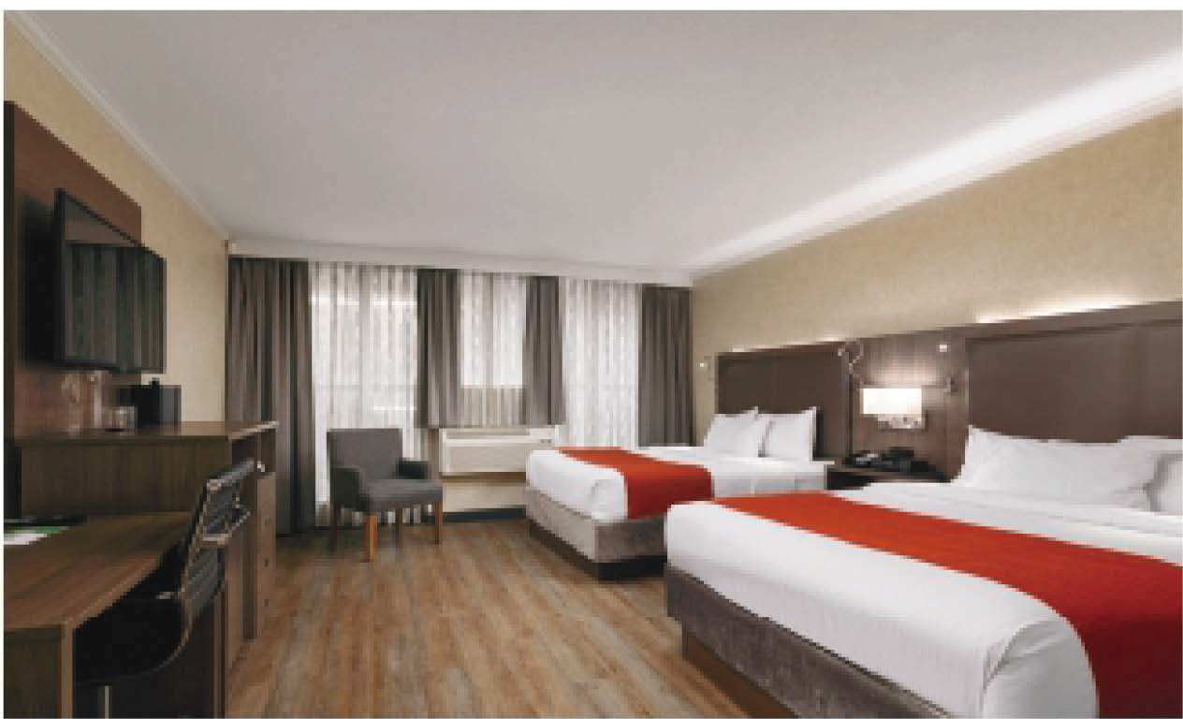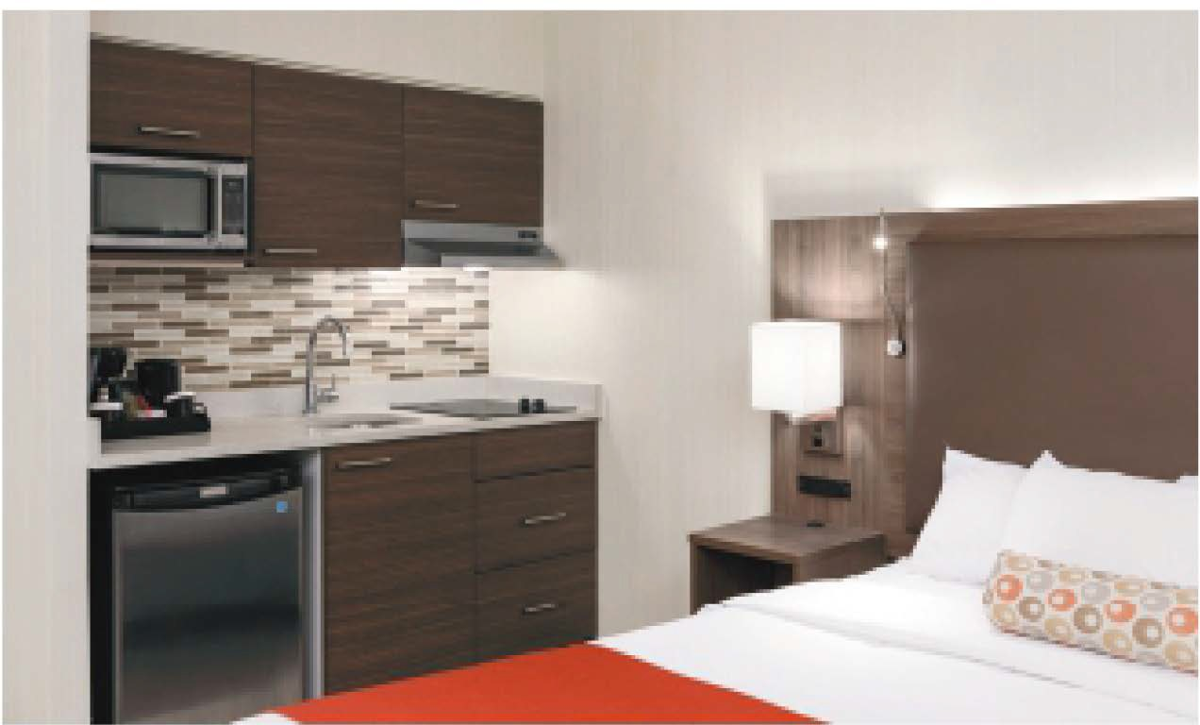

Suites are available for up to 2 guests. 16% tax not included. This rate will be credited to your long-term GEC stay. See full terms and conditions for details.

6

Global Education

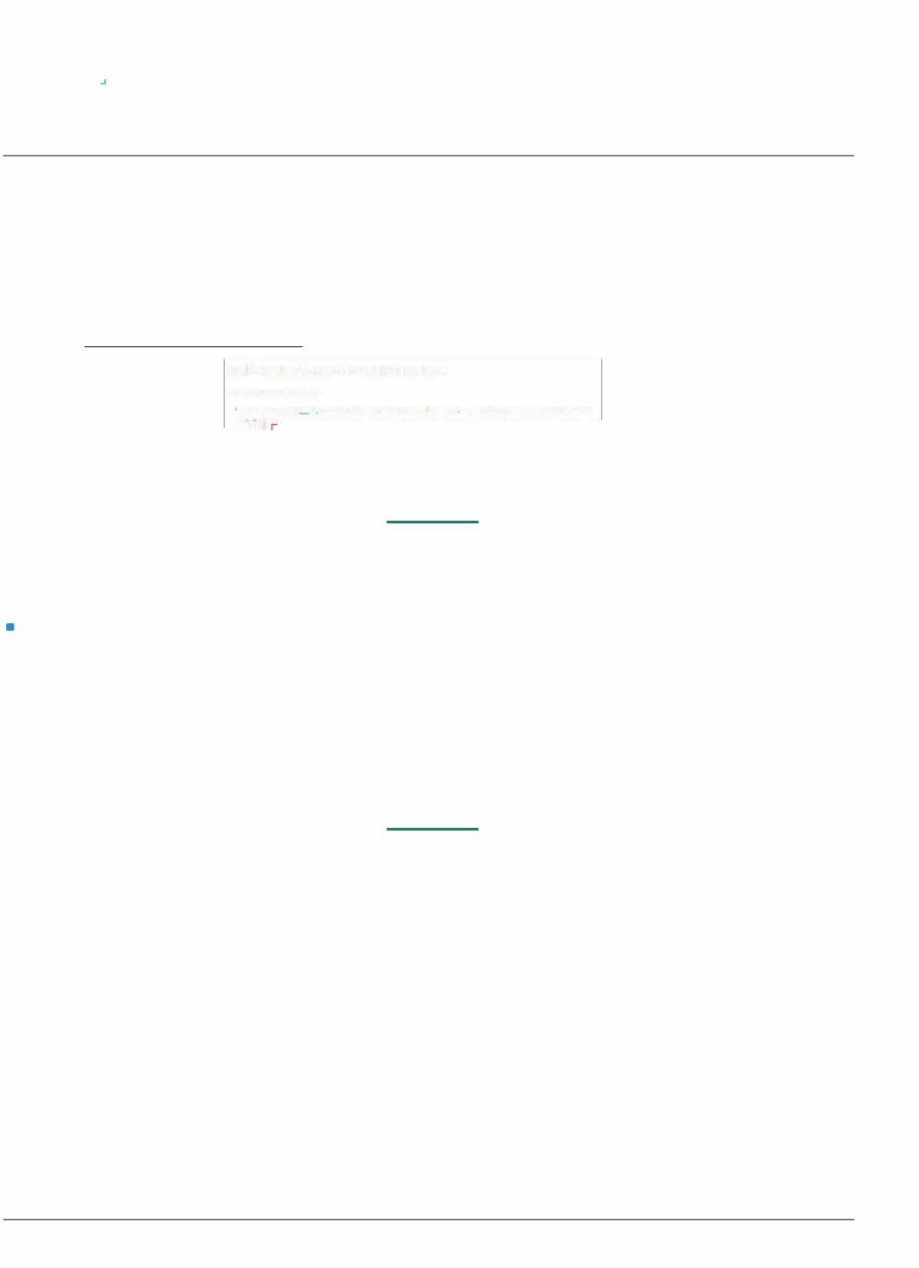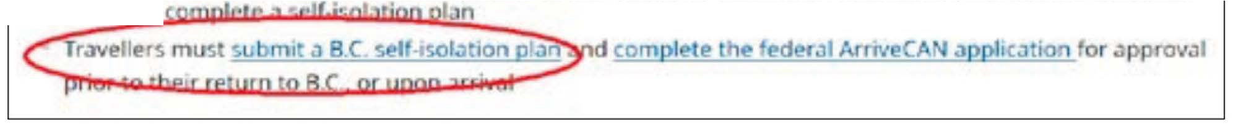

`Alliance

**BEFORE YOU ARRIVE CANADA**

Provincial Self-Isolation Plan

I• Here is a step-by-step guide for submitting the British Columbia

(BC) self-isolation plan BEFORE you travel to Canada:

1. Go to: the provincial government [Self-Isolation on Return to B.C.](https://www2.gov.bc.ca/gov/content/safety/emergency-preparedness-response-recovery/covid-19-provincial-support/self-isolation-on-return)
2. Click on the link above:

**Self-Isolation on Return to B.C.**

**Last Updated:Jun, 26, 2020**

**Unl•SS'fOUS>!il!如P1 31Hntem3do~”“vel如,e1um,n小0BC a”“牛”red切比YlO父II七，压e Ior 14**

For detailed steps of completing your [ArriveCAN Application](https://www.canada.ca/en/public-health/services/diseases/2019-novel-coronavirus-infection/latest-travel-health-advice.html#ua), please refer to **Appendix 1: self-isolation plan**

### ARRIVAL IN CANADA

Traveler entering Canada by air or by land must:

I provide basic information using the traveler contact information form,

available through

1. the [ArriveCAN mobile app](https://www.canada.ca/en/public-health/services/diseases/2019-novel-coronavirus-infection/latest-travel-health-advice.html#a_arriveCAN) (available for iOS or Android)
2. an accessible web-based form (3)

For detailed steps of completing your [ArriveCAN Application](https://www.canada.ca/en/public-health/services/diseases/2019-novel-coronavirus-infection/latest-travel-health-advice.html#ua), please refer to **Appendix 2: federal ArriveCAN application**

### ASSESSMENT ON ARRIVAL

<o> be screened by a border services officer or quarantine officer to assess symptoms

Public health measures for the traveler to Canada:

If you're travelling by air, you need to

* pass a health check conducted by airlines before you'll be allowed to board your flight
* wear a non-medical mask or face covering during travel (including to the place you'll quarantine).

Learn more about self-Isolation and self-monitoring, what to do if you get sick, and how to prevent the spread of COVID-19, please visit the BC Centr[e for Disease Control or](http://www.bccdc.ca/health-info/diseases-conditions/covid-19/self-isolation) call 1.604.412.0957 between 7:30 a.m. and 8 p.m. Pacific Time, seven days a week (available in over 110 languages).

7

Global Education

`Alliance

# APPEN DIX 1 - B.C. SELF-ISOLATION PLAN

The following are screenshot sample excerpts from Self-Isolation on Return to B.C as of 2020-07-16. For updated information and full details, please visit:

##### [Self-Isolation on Return to B.C.](https://www2.gov.bc.ca/gov/content/safety/emergency-preparedness-response-recovery/covid-19-provincial-support/self-isolation-on-return)

Fill out the first section and be sure to have the details of new Vancouver address

比＞ Pt』h|lC safery and emerg迩y <ervre｀ ＞三g豆羽盆paredne吓，且ponse & Recoverv. ＞ BC'｀ Re

**Self-Quarantine on Return to B.C.**

Unless you are exe『npt, all international travellers returning to B.C. are required by law to self-quarantine for 14 days and complete the federal ArriveCAN application prior to their return or upon arrival

Last updated: September 3, 2020 On this page

竺p|ete the federaI ArrlveCAN aRPhcatlon A欢区sment proces` on arnva|

Qptmn刁I CompIe『e a RC <eIf·(“'amntlne竺

匕迳上PmwnClal traveI

Optional: Complete a B.C. Self-Quarantine Plan

lnadditionto the f句eraI ArnveCAN Appllcatlon, travellers arnwng m B.C are encouraged to complete a self. quarantine plan. Comple{ing ,he plan mll heIp you prepare to selfquarantme successfulIy,rs,mponant to consider:

The Ioca,lon ofyour 14.day self.quarantme How you wlll mravel (o your quaranIine location Arrangmg the neces$“supporu,

Food Medica0ons Childwe

Cleaning supplies Pei care

social or famlly supporI

匡Note: The,orn\ does not work on In1erneI Explorer

Primary Contact Information Travel Information

．斤寸心me[poma,ycoo区t) ．归I几m论的ma”“缸I) .,..,小m..ULjU扣心m下江巴＇

．氏te of orth (yyyy/""'1dd) ·Phooeoom归

ILuc心，仁歹、S

丘心l（叩心几）

Coty ·知飞eITOt叩

心父父压t

Arr;val Information

·�而jD比叩im记凶

凶•�/Fl袖t从m坛1”11i 4十）

Self Isolation Plan

·-·印

O 氏没如

，知立F仄10,.eo.,叩

氏忒al Code(中缸八忒）

·o."仅』－正，一o一·一七｀Jf勺下叮父lf·立杠盯氏叩'

.0嘿心忒乙口，m－－1_，勺祁心吓e10碰心如1叩r°'，a~who釭心切卢心北m如噙记巩1，一 叩如一”s加｀＂叫右b丐心五．＂忒心～ 0心．－ －“朽团＂宅一',- L-l-－d'

W压tfomoft氓飞区心tmmllyoob比toyoor父lf,“'，“lloca，心＇｛斗'lM山）口氏幻凶记正比仁l吵"'ra呕叩心口T扣“心如n

，压仰纨'""血如收~叮~，.七··~··bf"沁，女f－ 叫平勺灯心'“'或一（心勺七·,..“1一出句eI

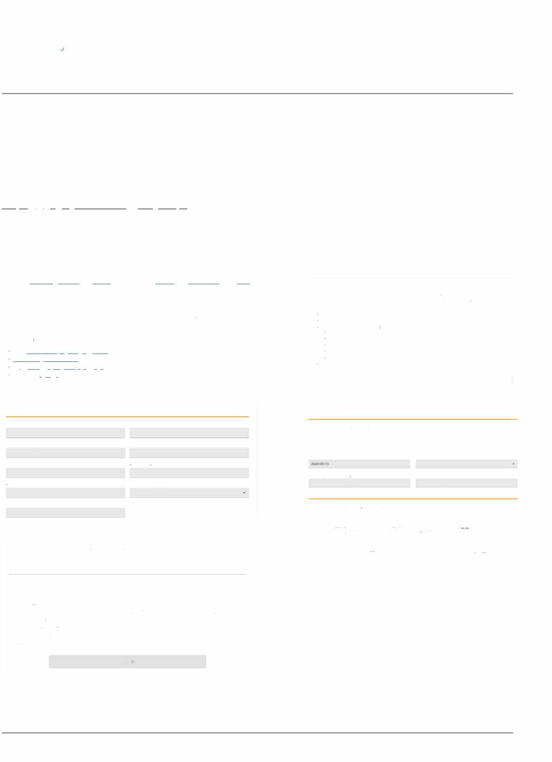

D,0fythisto比扛Umte`

�,“''""'七tl”

YOO『氏＂叩lhf”“'．，七心swdl芯，比0"仅』『如父比心KOl”“d切小eMini“”d戌冰huoo6加凶由“'tyd父欢ms2d斗位1e1ms27(1邸叨o八沁斤” dlnfqma如叩酝t«如d凸沁y心如氏blkHeal小儿t.OO心如mlQ旦'"加e沁tf口加仅叮沁妇0，心“飞如s”“doCOVlO·19氏沁·linf口叩如 m比如代dwlth仅”Q1心l沁·均，心沁门X九父“Ke,andf0如·up中rln，硕伈囡七，．女心血叩h沁叩qmmm”“mcemsa区辽心已l_，匕心下f 心PG如al bf"．如阰祀“'工t

n由·Mini叩dHeakhChiem.-，Offi，行

如心＄｀如众心－ l切3心，3工S'，田欢｛泊ElCV8W9P1 T4中l…~．236.478.，必

s,,".

Global Education

`Alliance

# APPENDIX 2 - FEDERAL ARRIVECAN APPLICATION

The following are screenshot sample excerpts from ArriveCAN App

Download the APP: ArriveCAN from: iPhone: [Click here](https://apps.apple.com/us/app/canarrive/id1505394667?mt=8)

Android: [Click here](https://play.google.com/store/apps/details?id=ca.gc.cbsa.coronavirus)

It will ask your preferred language. Choose one language and click "Start"

C.mad罚

ThS,ppl论sto忒Ii几飞min9tra亿II.“arrw叩in cmada Pleaseu沈the tooIs以1ow, ba如“ 叩rpomt ofentry，upGRwrNal to submittoveIler infGma t心nrequir织切bwasindicat的bya ma心ato”fieid

-

Ent,y into Canada by Ai,

F,I out OI”mtm田巾'SQ心I口m,I~·氓fly,ngtoC富口中

En行y ;nto Canada by Land

flI oot or”mtm顷加s q兀K 缸m,＇＂刀·,··“'”mgC．心心

今

"．代

hlC1.“byIOO,

Voew you, Ent,y onto Canada Code

Your Flight into Canada A叩“'

V虹OU`rImematmaIAir仁m

A冒''"'

Ai『China

Fl'寸tN,mbo, CA991

Dt.ofAmvai

2020-05-04 00,00

Pr如OUS -

年

Add Traveller

Qe,tinahon ty..

COVID-19 Self-Assessment Quarantine Plan

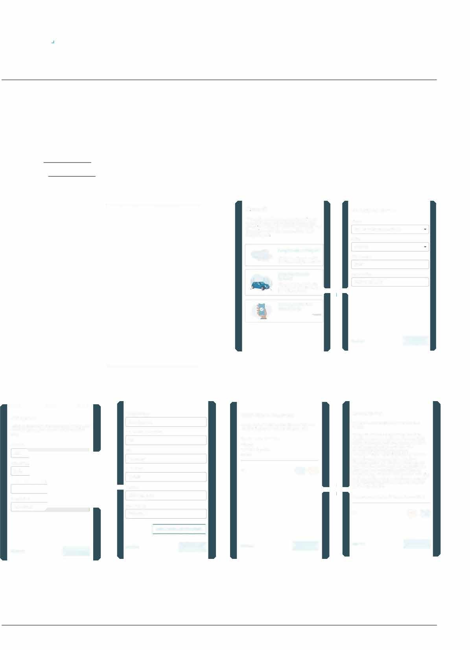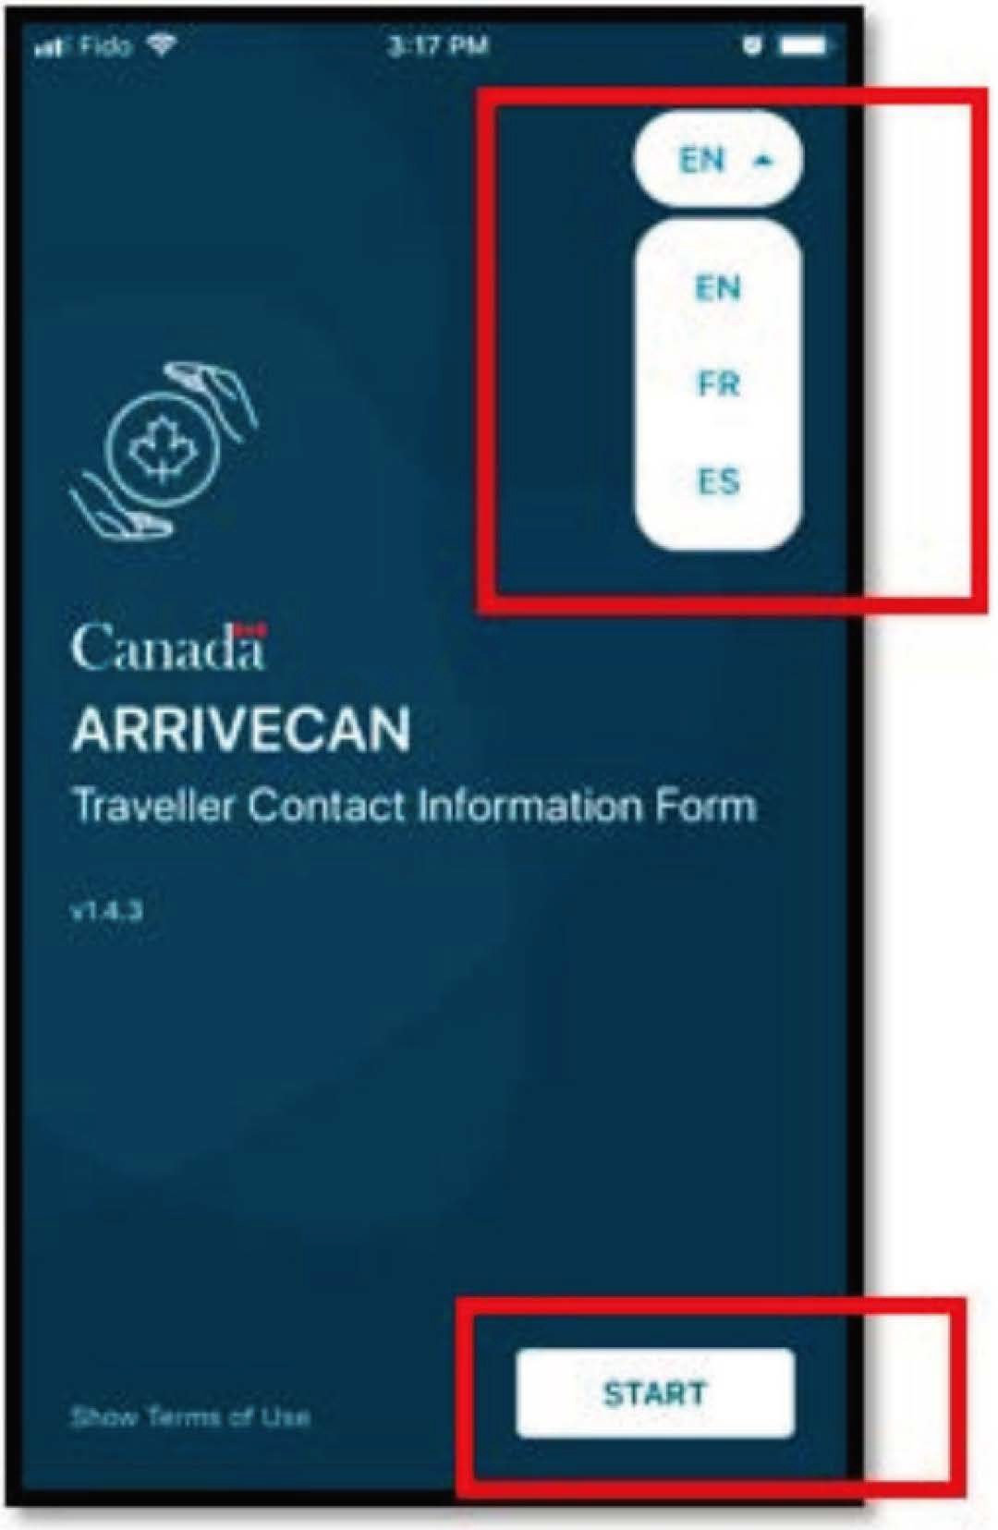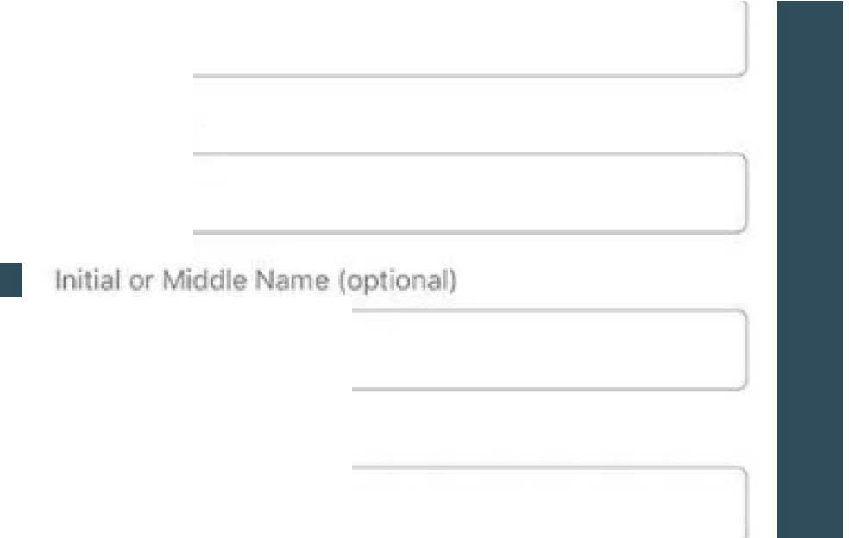

A改“ou,detaitshe『e.lf沁aretra茂lli叨as“'tof a fam;� o, gtoup, yo u cao的dmu1dp|etravel妇s after.

Su『na汀冷

First Na

0ateofB'，th 2000-05-04

－

“evlou$

9

Rei,rning home

Stf妇Inamea心心m归123

c,,,

Vane心W打Postar」Yi?

V1H1J3

今－ P心"<•

British Columbia

Dateofarnval 2020-05-06

＿

| ADD ANOTHERDESTINATlON I

PmviOU$

AremUGanyoftheIravdI还list釭lonlhls缸m expGencmg anyof thefollovmg symptoms?

Symp,om$amdefin”ias:

* Cough

旧,,

．凶f匕ultyb,ea

BA 0@

今

Previous ＿

You must have aq顷rantineplan for the啦t 14days.

OJarantinemeansst呼叩hemeandambi叩 situationsw氏re yQ,couldcomeincont沁twith othm Y“'rplans如ldconfrmt归tyeu归ve a suita以eplace ofqua,antinethat has the neces玑iesof1ifefor14 days;pwate

trans""'tat ion totheprem乃esif possi以e; acces, to supplies s心has”.SC『iptions, f00dand clean，飞”"P�沦S,andotherneces均＂沁pport s”:has ch心ca『,. Do not ploo to q心r antinein a pl忒ewhere you ha由Cont忒t with,u lne,a以e hdiv"山lS,incl心l叩t叩wttoha"'anund印ymg medical condition, comp,omlsedlmm,oe system froma m«iiclcondh;“”xt巾atmGt, oram65 y的rsofa9.“°心r

Doyouha,eaplanfo『14day,ofq四rantine?

＿

BA 00

p,evi“'

Global Education

`Alliance

# APPENDIX 3 - TIPS FOR SAFER SOCIAL INTERACTIONS

When going out in public, it is important to stay at least 6 feet away from other people and wear a mask to slow the spread of COVID-19. Consider the following tips for practicing social distancing when you decide to go out.

＿

What does physical distancing

0川e

台

。e川

雹0 0

彰

啥岱

mean?

This means making changes in your everyday routines in order to minimize close contact with others, including:

* + avoiding crowded places and non-essential gatherings
  + avoiding common greetings, such as handshakes

句

* + limiting contact with people at highe「risk (e.g. older adults and those in poo「 health)
  + keeping a distance of at least 2 arms lengths (approximately 2 metres) from others, as much as possible

Here's how you can practise physical distancing:

* + greet with a wave instead of a handshake, a kiss or a hug
  + stay home as much as possible, including for meals and entertainment
  + grocery shop once per week
  + take public transportation during off- peak hours
  + conduct virtual meetings
  + host virtual playdates for your kids
  + use technology to keep in touch with friends and family

If possible,

* + use food delivery services or on line
  + exercise at home or outside
  + work from home
  + wash your hands often for at least 20 seconds and avoid touching your face
  + cough or sneeze into the bend of your arm
  + avoid touching surfaces people touch often
  + self-monitor for symptoms of COVID-19 including:

cough

* + - feve「
    - difficulty breathing

If you'『e concerned you may have COVID-19:

* + separate yourself from others as soon as you have symptoms
  + if you are outside the home when a symptom develops. go home immediately

and avoid taking public transit

* + stay home and follow the advice of your Public Health Authority,

who may recommend isolation

* + call ahead to a health care provider if y.o.u..a.re ill a.n.d..s.e,.e,king medi'c.a..l a.t.t.e.n.t.ion **NOTE:** Some people may transmit COVID-19 even though they do not

，•＇••

．

show any **symptoms**. I� situat.i.��s where physical distancing is difficult to mamtain, wearinf a **non-medical mask or face covering** ( i. e. made with at least two layers of tightly woven

fabric, **constructed** to completely cover the nose and mouth without gaping, and secured to the head by ties or ear loops) provi�es a barrie�

�etween your 「espiratory droplets and

the people and surfaces around you. It may also stop you from touching your nose or mouth, which is another way

.................．

the virus can get into your body. ，

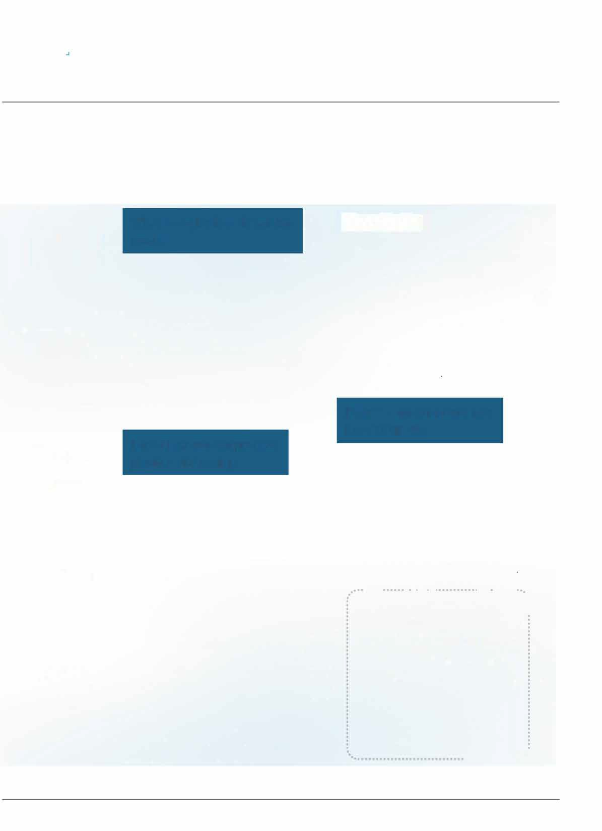

FOR MORE INFORMATION: [canada.ca/coronavirus](https://www.canada.ca/en/public-health/services/diseases/coronavirus-disease-covid-19.html?utm_campaign=not-applicable&utm_medium=vanity-url&utm_source=canada-ca_coronavirus) or call 1-833-784-4397

